
UNIT III: ORGANIZING

WHAT IS ORGANIZING?

"Organizationing is the process of identifying and grouping of the works to be performed, defining and delegating responsibility and authority and establishing relationships for the purpose of enabling people to work most efficiently".
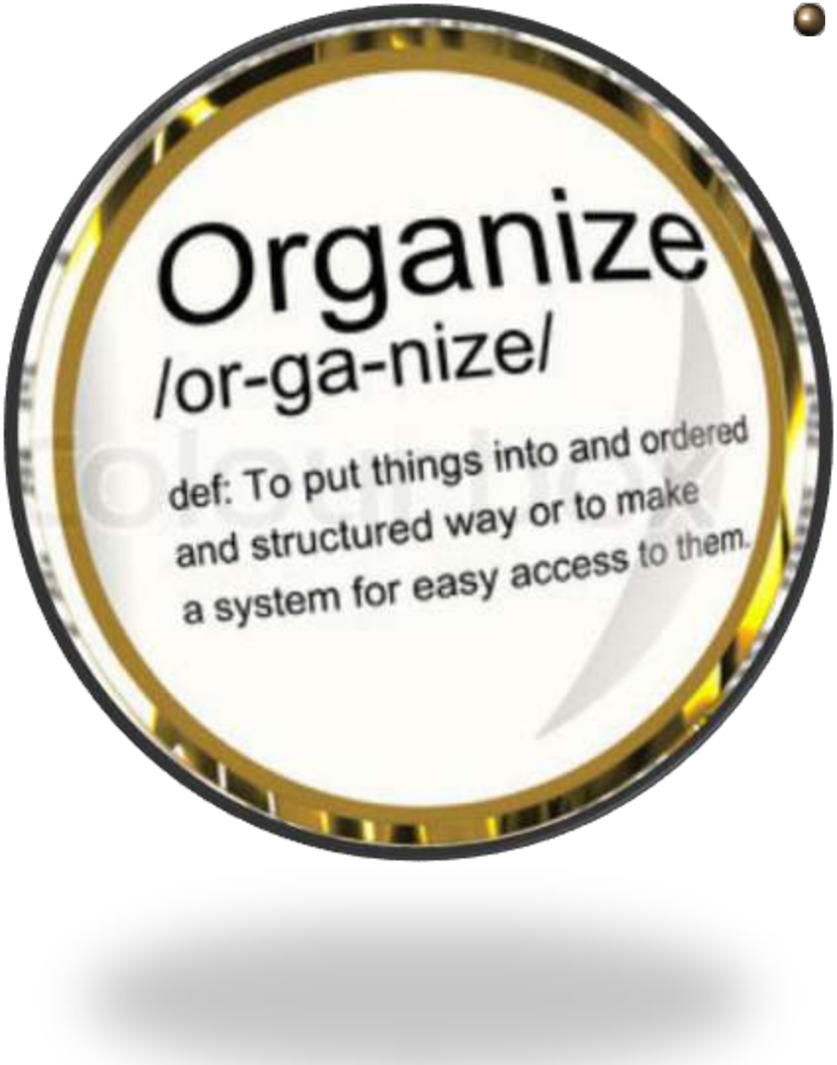

- Louis A. Allen

FUNDAMENTAL CONCEPT OF ORGANIZING:

- DIFFERENTIATION: It means that an organization is composed of units that work on specialized tasks using different work methods and requiring employees with unique competencies.

- INTEGRATION: It means that the various units must be put back together so that work is coordinated.
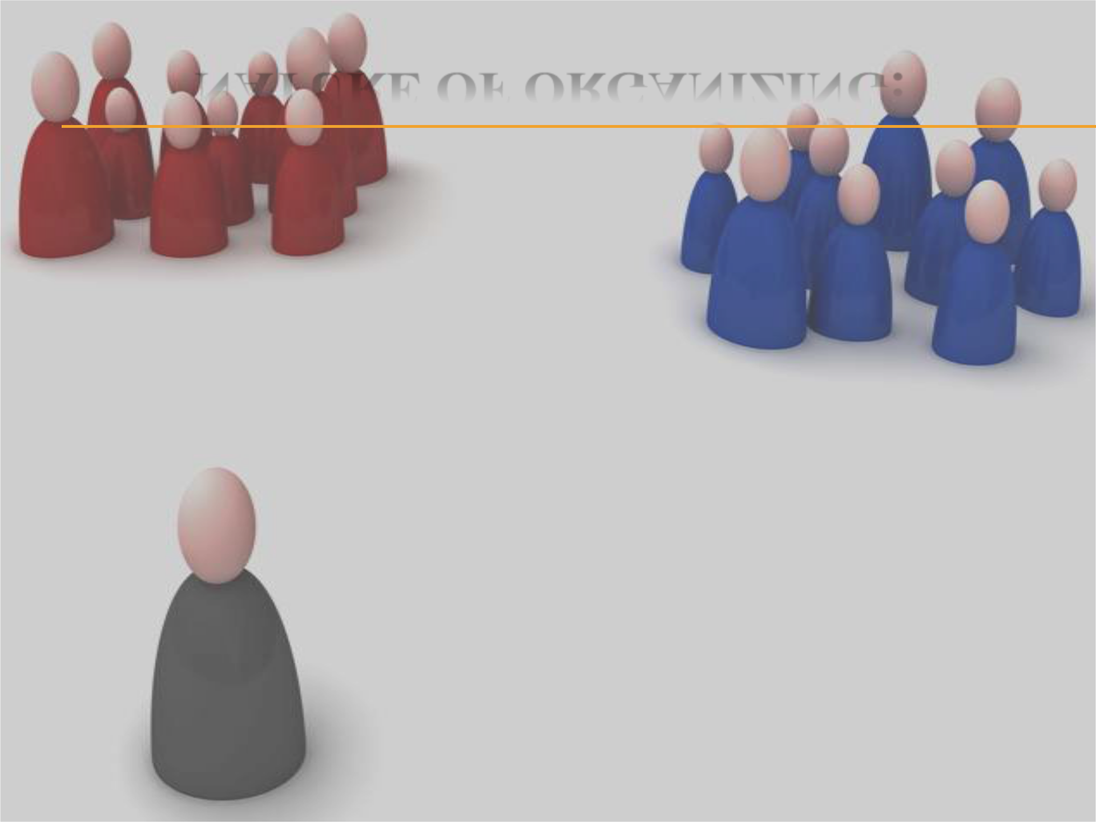
NATURE OF ORGANIZING:

1. Group of Persons

2. Common Objectives
5. Communication
3. Division of Work
6. Central Authority
4. Cooperative Efforts
7. Rules & Regulations

8. Dynamic Element
NATURE OF ORGANIZATION:

- Group of Persons: An organization is a group of people working together for the achievement of common objectives. The group may be large or small. An organization is a system of cooperative relationships of two or more persons.

- Common Objectives: Every organization has a common objectives distinct from personal objectives of the members. The common goal is the basis of cooperation among the members. The objectives of the organization are usually are made explicit
CONTD:

- Division of Work: An organization comes into existence when the total task is divided into the members of the group. Division of work is necessary not only because one individual cannot do all the work but specialization results in efficiency and effectiveness.

- Cooperative Efforts: The members of an organization are willing to help each other for the achievement of desired goals. Cooperative relationships are stabilized both vertically and horizontally among different units of the organization:
CONTD:

- Communication: People who form an organization communicates with each other in order to integrate or coordinate there efforts. The structure must be such that people can perform together efficiently.

- Central Authority: In an organization, there is a central directing authority which controls the concerted efforts of the group. The chain of authority- responsibility relationships is known as the chain of command.

- Rules and Regulations: For the orderly and systematic working of the members, rules and regulations are laid down and enforced by the central authority.

- The Dynamic Element: An organization is not a mere mechanical structure but a living organism arising out of the sentiments, attitudes, and behavior of people. The people are the material of construction that holds the structure together and gives it vitality.
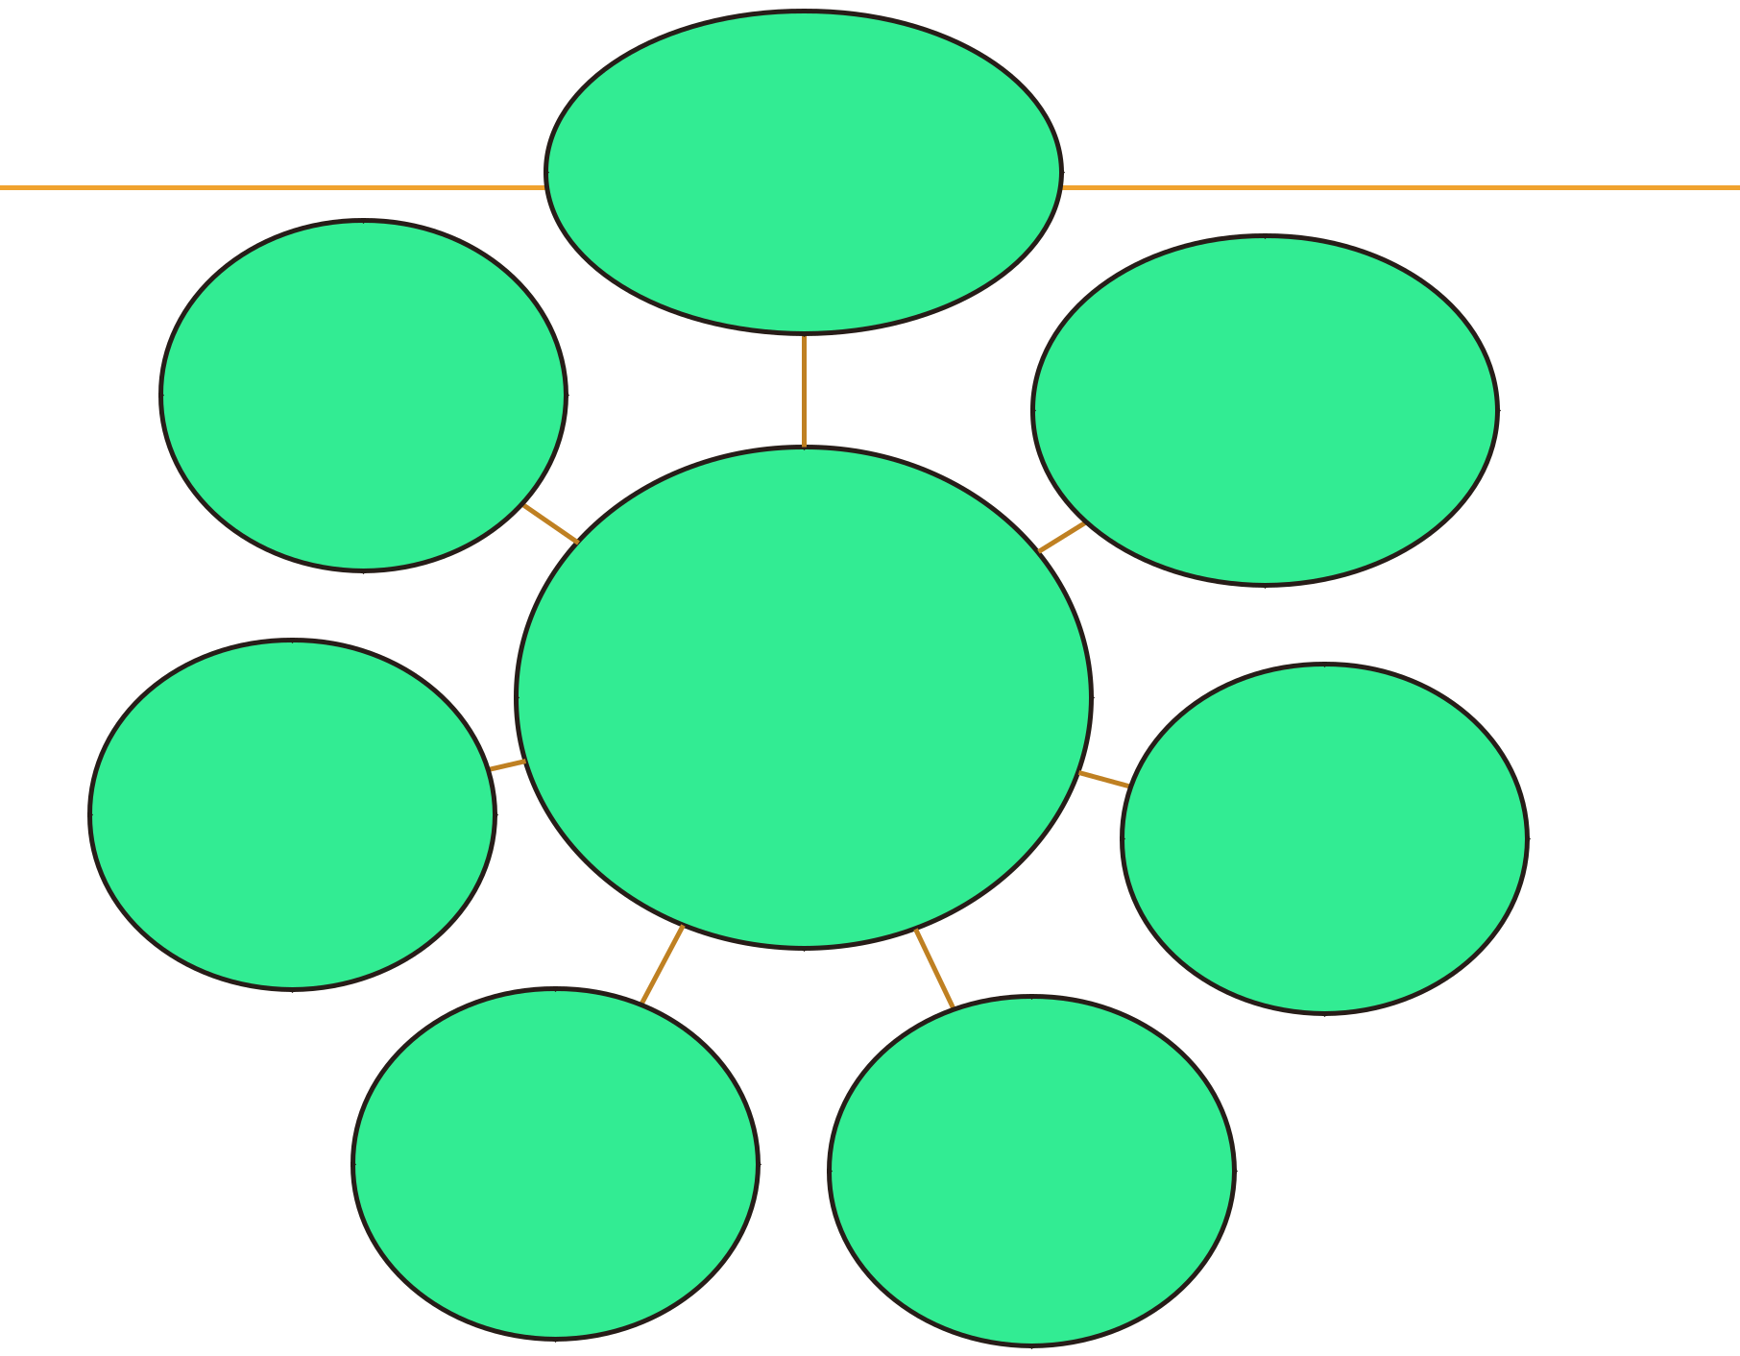
- Facilitates Administration

7. | 2. Encourages
Coordination | Growth &
 | Diversification

6. Ensures | 3. Optimum
Continuity of | 3. Optimum
Continuity of | Use of
Enterprise | Use of
Enterprise | Technology

IMPORTANCE OF
ORGANIZING

5. Encourages | 4. Stimulates
Good Human | Innovation &
Relations | Technology

IMPORTANCE OF ORGANIZING:

- Facilitates Administration: Achievement of the objectives of an enterprise by providing a framework of coordination and control. It provides a system of authority and network for effective communication. Individual goals can be coordinated towards group goals. A properly balanced organization facilitated both management and operation of the enterprise.

- Encourages Growth & Diversification: It has enabled organizations to grow and expand to giant sizes. Systematic division of work and consistent delegation of authority facilitate taking up of new activities and meeting new demands. It provides flexibility for growth without losing control over various activities.
CONTD…

- Optimum Use of New Technology: It is made through a sound structure manned with competent employees. In addition, Optimum use of technology permits optimum utilisation of human resources. Sound organization ensures that every individual is placed on the job for which one is best suited.

- Stimulates Innovation & Creativity: It stimulates creative thinking and initiative on the part of employees. It provides for effective management of change and responds favourably to changes in environment. It provides recognition for the professional and the specialist in terms of their achievement.
- Encourages Good Human Relations: The assignment of right jobs to right person improves job satisfaction and inter-personal relations. Well-defined jobs and clear lines of authority and responsibility ensure good human relations.

- Ensures Continuity of Enterprise: It provides scope for the training and development of future management. It provides avenues for development and promotions through delegation and decentralisation.

- Coordination: It facilitates order and cohesiveness in the enterprise. Division of labor, better utility of technology and human talent helps to improve the efficiency and quality of work. Clear channels of communication among the members of the organization leads to coordination.
PROCESS:
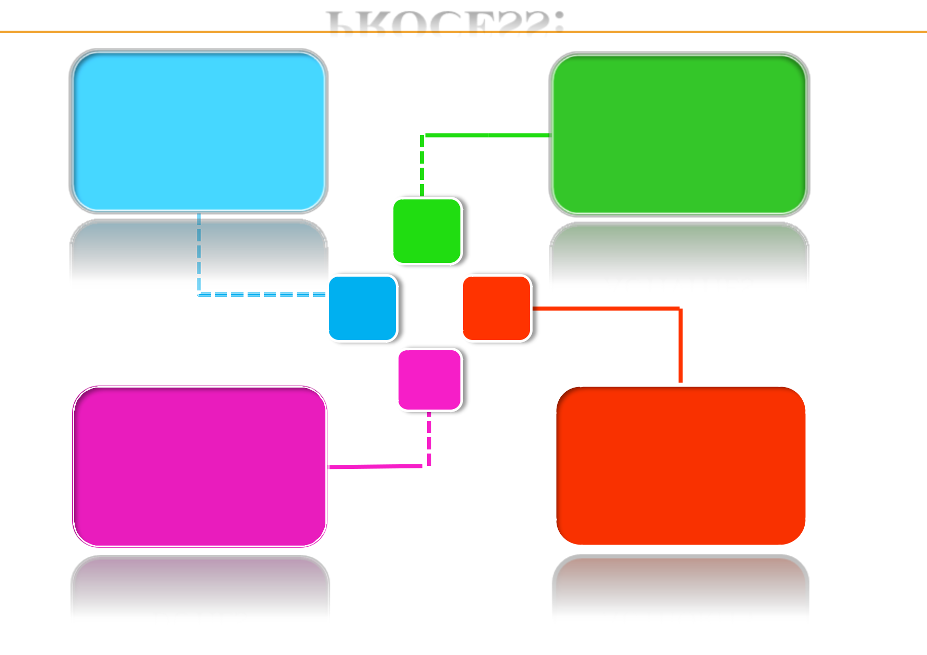

IDENTIFICATION | GROUPING OF
OF ACTIVITIES | ACTIVITIES

2.

1. 3.

4.

ASSIGNMENT OF DELEGATION OF

DUTIES AUTHORITY

PROCESS OF ORGANIZING:

- Identification of Activities: First step is to determine the tasks that must be performed to achieve the established objectives. Activities and jobs are building blocks of any organization. The activities to be performed depends upon the objectives, nature and size of the enterprise.

- Grouping of Activities: The various activities are the grouped into departments or divisions according to similarity and common purpose. Such grouping is necessary for the purpose of specialization, coordination and control. It may be grouped on various basis i.e. functions products, territories, customers etc depending on requirements.
- Assignment of Duties: Groups of activities or departments are then allotted to different positions. Every position is occupied by an individual best suited for it. The assignments of activities creates responsibility and ensures certainty of work performance. The process should be carried down to the lowest levels. It is basically done to avoid duplication of work and over-lapping efforts.

- Delegation of Authority: Every individual is given the authority required to carry out the responsibility assigned to him. A chain of command is created through successive delegation of authority. Different positions are linked vertically and horizontally by establishing formal authority. Every individual must know to whom he is accountable and who are his subordinates.

Every company has an organizational structure. It helps the employees understand the hierarchy and the communication channels of the firm. No company can function efficiently without some form of organization. The choice of the organizational structure depends on the size of the firm among other factors

Organizations are basically clasified on the basis of relationships. There are two types of organizations formed on the basis of relationships in an organization
- Formal Organization - This is one which refers to a structure of well defined jobs each bearing a measure of authority and responsibility. It is a conscious determination by which people accomplish goals by adhering to the norms laid down by the structure. This kind of organization is an arbitrary set up in which each person is responsible for his performance. Formal organization has a formal set up to achieve pre- determined goals.
- Informal Organization - It refers to a network of personal and social relationships which spontaneously originates within the formal set up. Informal organizations develop relationships which are built on likes, dislikes, feelings and emotions. Therefore, the network of social groups based on friendships can be called as informal organizations. There is no conscious effort made to have informal organization. It emerges from the formal organization and it is not based on any rules and regulations as in case of formal organization.

Relationship between Formal and Informal Organizations
For a concerns working both formal and informal organization are important. Formal organization originates from the set organizational structure and informal organization originates from formal organization. For an efficient organization, both formal and informal organizations are required. They are the two phase of a same concern.
Formal organization can work independently. But informal organization depends totally upon the formal organization.
Formal and informal organization helps in bringing efficient working organization and smoothness in a concern. Within the formal organization, the members undertake the assigned duties in co-operation with each other. They interact and communicate amongst themselves. Therefore, both formal and informal organizations are important. When several people work together for achievement of organizational goals, social tie ups tends to built and therefore informal organization helps to secure co-operation by which goals can be achieved smooth. Therefore, we can say that informal organization emerges from formal organization.

An organizational structure is a system that outlines how certain activities are directed in order to achieve the goals of an organization. These activities can include rules, roles, and responsibilities. The organizational structure also determines how information flows between levels within the company.

Types of Organizational Structures: their Advantages and Disadvantages!
The formal organisation in usually delineated by an organisational chart and job descriptions. The official reporting relationships are clearly known to every manager.
Alongside the formal organisation exists are informal organisation which is a set of evolving relationships and patterns of human interaction within an organisation that are not officially prescribed.
Formal organizational structures are categorized as
(i) Line organisational structure.
(ii) Staff or functional authority organisational structure.
(iii) Line and staff organisational structure.
(iv) Committee organisational structure
(v) Divisional organisational structure.

(vi) Project organisational structure.
(vii) Matrix organisational structure and
(viii) Hybrid organisational structure.
These organisational structures are briefly described in the following paragraphs:

1. Line Organisational Structure:
A line organisation has only direct, vertical relationships between different levels in the firm. There are only line departments-departments directly involved in accomplishing the primary goal of the organisation. For example, in a typical firm, line departments include production and marketing. In a line organisation authority follows the chain of command.
illustrates a single line organisational structure.
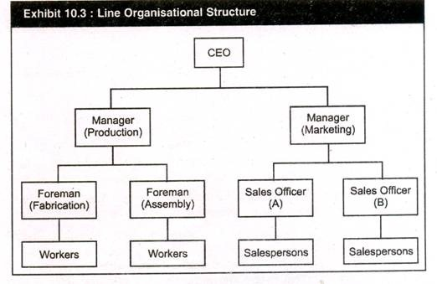
Features:
Has only direct vertical relationships between different levels in the firm.
Advantages:
1. Tends to simplify and clarify authority, responsibility and accountability relationships
2. Promotes fast decision making
3. Simple to understand.
Disadvantages:
1. Neglects specialists in planning
2. Overloads key persons.
Some of the advantages of a pure line organisation are:
(i) A line structure tends to simplify and clarify responsibility, authority and accountability relationships. The levels of responsibility and authority are likely to be precise and understandable.
(ii) A line structure promotes fast decision making and flexibility.
(iii) Because line organisations are usually small, managements and employees have greater closeness.
However, there are some disadvantages also. They are:

(i) As the firm grows larger, line organisation becomes more ineffective.
(ii) Improved speed and flexibility may not offset the lack of specialized knowledge.
(iii) Managers may have to become experts in too many fields.
(iv) There is a tendency to become overly dependent on the few key people who an perform numerous jobs.

Line and Staff Organization
Line and staff organization is a modification of line organization and it is more complex than line organization. According to this administrative organization, specialized and supportive activities are attached to the line of command by appointing staff supervisors and staff specialists who are attached to the line authority. The power of command always remains with the line executives and staff supervisors guide, advice and council the line executives. Personal Secretary to the Managing Director is a staff official.
MANAGING DIRECTOR
↓ | ↓ | ↓
Production Manager | Marketing Manager | Finance Manager hr mgr
↓ | ↓ | ↓
Plant Supervisor | Market Supervisor | Chief Assistant
↓ | ↓ | ↓
Foreman | Salesman | Accountant

Features of Line and Staff Organization
- There are two types of staff :
  - Staff Assistants- P.A. to Managing Director, Secretary to Marketing Manager.
  - Staff Supervisor- Operation Control Manager, Quality Controller, PRO
- Line and Staff Organization is a compromise of line organization. It is more complex than line concern.
- Division of work and specialization takes place in line and staff organization.
- The whole organization is divided into different functional areas to which staff specialists are attached.
- Efficiency can be achieved through the features of specialization.
- There are two lines of authority which flow at one time in a concern :
  - Line Authority
  - Staff Authority
- Power of command remains with the line executive and staff serves only as counselors.

Merits of Line and Staff Organization
- Relief to line of executives- In a line and staff organization, the advice and counseling which is provided to the line executives divides the work between the two. The line executive can concentrate on the execution of plans and they get relieved of dividing their attention to many areas.
- Expert advice- The line and staff organization facilitates expert advice to the line executive at the time of need. The planning and investigation which is related to different matters can be done by the staff specialist and line officers can concentrate on execution of plans.
- Benefit of Specialization- Line and staff through division of whole concern into two types of authority divides the enterprise into parts and functional areas. This way every officer or official can concentrate in its own area.
- Better co-ordination- Line and staff organization through specialization is able to provide better decision making and concentration remains in few hands. This feature helps in bringing co-ordination in work as every official is concentrating in their own area.
- Benefits of Research and Development- Through the advice of specialized staff, the line executives, the line executives get time to execute plans by taking productive decisions which are helpful for a concern. This gives a wide scope to the line executive to bring innovations and go for research work in those areas. This is possible due to the presence of staff specialists.
- Training- Due to the presence of staff specialists and their expert advice serves as ground for training to line officials. Line executives can give due concentration to their decision making. This in itself is a training ground for them.
- Balanced decisions- The factor of specialization which is achieved by line staff helps in bringing co-ordination. This relationship automatically ends up the line official to take better and balanced decision.
- Unity of action- Unity of action is a result of unified control. Control and its effectivity take place when co-ordination is present in the concern. In the line and staff authority all the officials have got independence to make decisions. This serves as effective control in the whole enterprise.

Demerits of Line and Staff Organization
- Lack of understanding- In a line and staff organization, there are two authority flowing at one time. This results in the confusion between the two. As a result, the workers are not able to understand as to who is their commanding authority. Hence the problem of understanding can be a hurdle in effective running.
- Lack of sound advice- The line official get used to the expertise advice of the staff. At times the staff specialist also provide wrong decisions which the line executive have to consider. This can affect the efficient running of the enterprise.
- Line and staff conflicts- Line and staff are two authorities which are flowing at the same time. The factors of designations, status influence sentiments which are related to their relation, can pose a distress on the minds of the employees. This leads to minimizing of co-ordination which hampers a concern’s working.
- Costly- In line and staff concern, the concerns have to maintain the high remuneration of staff specialist. This proves to be costly for a concern with limited finance.
- Assumption of authority- The power of concern is with the line official but the staff dislikes it as they are the one more in mental work.
- Staff steals the show- In a line and staff concern, the higher returns are considered to be a product of staff advice and counseling. The line officials feel dissatisfied and a feeling of distress enters a concern. The satisfaction of line officials is very important for effective results.

Matrix Organisational Structure

This is also called project organisation. It is a combination of all relationships in the organisation – vertical, horizontal and diagonal. It is mostly used in complex projects. It provides a high degree of operational freedom, flexibility and adaptability for both the line and the staff managers in performing their respective roles.

Below Figure shows a president having three vice-presidents, each representing a functional area – production, finance, and sales. Additionally, there are two project managers for two locations A and B. The figure reveals that both the functional manager and the project manager exercise authority over those working in the matrix unit.
The president coordinates or balances power between the functional and the project managers. Each work group (represented by a square on the matrix) is held uniquely accountable to two supervisors.
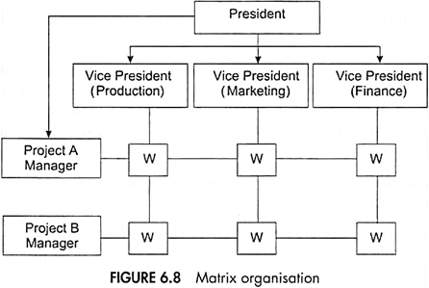

The matrix organisation can be evaluated in terms of the following merits and demerits:
Merits:
a. It offers operational freedom and flexibility.
b. It seeks to optimise the utilisation of resources.
c. It focuses on end results.
d. It maintains professional identity.
e. It holds an employee responsible for management of resources.
Demerits:
a. It calls for greater degree of coordination.

Matrix Organisational Structure
Everything you need to know about Matrix Organisational Structure. Matrix Organisational Structure is a combination of functional organisation and project organisation (i.e. Matrix Organisation = Functional Structure + Project Structure).
It consists of groups of persons, drawn from various functional departments and deputed to work on a project under the guidance and direction of a Project Manager appointed by the top management.
According to Stanley Davis and Paul Lawrence, matrix organisation is, “Any organisation that employs a multiple command structure but also related support mechanisms and an associated organisational culture and behaviour pattern”.
ADVERTISEMENTS:
The matrix organisation may be followed where a large number of small projects have to be managed.
Learn about:- 1. Definition of Matrix Organization 2. Features of Matrix Organisation 3. Evaluation 4. Merits 5. Demerits 6. Conditions for Effective Matrix Organisation.

Matrix Organisational Structure: Definition, Features, Evaluation, Merits, Demerits and Conditions

Matrix Organisational Structure – Evaluation, Merits and Demerits
This is also called project organisation. It is a combination of all relationships in the organisation – vertical, horizontal and diagonal. It is mostly used in complex projects. It provides a high degree of operational freedom, flexibility and adaptability for both the line and the staff managers in performing their respective roles.
The main objective of matrix organisation is to secure a higher degree of coordination than what is possible from the conventional organisational structures such as – the line and staff.
ADVERTISEMENTS:
Figure 6.8 shows a president having three vice-presidents, each representing a functional area – production, finance, and sales. Additionally, there are two project managers for two locations A and B. The figure reveals that both the functional manager and the project manager exercise authority over those working in the matrix unit.
The president coordinates or balances power between the functional and the project managers. Each work group (represented by a square on the matrix) is held uniquely accountable to two supervisors.
Evaluation:
ADVERTISEMENTS:
The matrix organisation is increasingly used in high-technology enterprises but there are cases of many failures also. Matrix organisations have one striking advantage – flexibility and optimisation of resources. Work groups, along with its resources, can be shifted from one project to the other, depending upon the exigency.
When the project is completed, they return to their functional departments. The process of monitoring and controlling the work groups is easier since the workers are under the charge of one project manager from the beginning to the end.
One of the shortcomings of matrix organisation is that it does not observe the principle of ‘one employee, one superior’. However, as long as the managers are aware of their roles, things go well. In other words, the authority and responsibility relationships, in case of matrix organisation, need precise definition.
Otherwise, the workers suffer from the overlapping and conflicting authority and responsibility. Working with two taskmasters may, at times, result in suffocating, disgusting, and frustrating experience. This may lead to inertia and lack of motivation also. Much before this happens, it is advisable that the top management appoints a general manager (Projects) for coordinating the project managers and the functional managers to settle the differences, if any.

Matrix organization can be evaluated in terms of the following merits and demerits:
Merits:
a. It offers operational freedom and flexibility.
b. It seeks to optimize the utilization of resources.
c. It focuses on end results.
d. It maintains professional identity.
e. It holds an employee responsible for management of resources.

Demerits:
a. It calls for greater degree of coordination.
b. It violates unity of command principle.
c. It may be difficult to define authority and responsibility precisely.
d. Employees may find it frustrating to work with two bosses

Advantages:
The advantages of matrix organisation are as under:
(i) The matrix structure is an efficient means for bringing together the diverse specialised skills required to complete a complex assignment or execute a project.
(ii) It is flexible in nature. It can be applied more usefully to an organisation involved in projects ranging from small to large. It can better respond to the changes in technology, market conditions, etc.
(iii) It motivates personnel engaged in the project. They can utilise their competence and make maximum contribution for the execution of the project. It also improves communication and coordination by facilitating direct contact between the project manager and the functional groups.
(iv) It provides a balance between time, cost and performance. The balance can be achieved through the built-in checks and balances and the continuous negotiations carried on between project and functional personnel.
(v) It helps in improving flow of communication around the organisation as required information is communicated both vertically as well as horizontally.
(vi) It encourages specialisation and organisation gets benefits and economies arising out of specialisation since specialised central pools are created in the form of functional departments providing specialised services and resources to project units.

Limitations:
The limitations of matrix structure are as follows:
(i) The matrix organisation violates the classical principle of unity of command. The personnel from functional departments have to face the situation of two bosses, project manager and functional manager. As a result, a functional group may side track his responsibility easily if project unit fails in achieving its goal.
(ii) In matrix organisation, the problem of coordination is more complicated because neither functional head has an authority over project unit in a direct manner nor the project manager has full authority over project activities. The project manager works as coordinator and facilitator but without required authority.
(iii) Matrix organisation is not a homogeneous and compact group. The multiplicity of vertical and horizontal relationships may impair organisational efficiency. Deputationists may try to emphasise their own specialisations at the cost of the overall project. There is lack of jurisdictional clarity.
(iv) Apart from formal relationships, informal ones also operate in the matrix organisation. Thus, organisational relationships become more complex and they create the problem of co-ordination.
(v) Dual reporting relationship in matrix organisation can contribute to indiscipline, ambiguity and role conflict. The functional representative who is subject to dual command cannot satisfy the priorities of both the bosses.
(vi) Each project manager is charged with the successful implementation of his project. For this, each project manager has to share resources with other project managers. This might create rivalry between various project managers.

Departmentation is the foundation of organisation structure. Departmentation means division of work into smaller units and their re-grouping into bigger units (departments) on the basis of similarity of features. Each department is headed by a person known as departmental manager. Division of work into departments leads to specialisation as people of one department perform activities related to that department only. Departmentation provides scope for organisation’s growth (along the same product lines) and expansion (addition of new product lines).

Meaning of Departmentalisation:
‘Departmentation’ or ‘Departmentalisation’ is the process of grouping the activities of an enterprise into several units for the purpose of administration at all levels.
The administrative units so created may be designated as departments, divisions, units, branches, sections, etc.

The process of organising consists of dividing and grouping of the works to be done in an enterprise and assigning different duties and responsibilities to different people.
Dividing the work naturally means the identification of individual activities which have to be undertaken for the attainment of the organisational objectives. But once the various activities have been identified, it is necessary to group them together on some logical basis so that a team can be organised.
Departmentation can provide a necessary degree of specialisation of executive activity for efficient performance. It can simplify the tasks of management within a workable span. It also provides a basis on which the top managers can co-ordinate and control the activities of the departmental units.

Need for and Importance of Departmentation:
The basic need for departmentation is to make the size of each departmental unit manageable and secure the advantages of specialisation. Grouping of activities and, consequently, of personnel, into departments makes it possible to expand an enterprise to any extent.
Departmentation is necessary on account of the following reasons:

1. Advantages of Specialisation:
Departmentation enables an enterprise to avail of the benefits of specialisation. When every department looks after one major function, the enterprise is developed and efficiency of operations is increased.

2. Feeling of Autonomy:
Normally departments are created in the enterprise with certain degree of autonomy and freedom. The manager in charge of a department can take independent decisions within the overall framework of the organisation. The feeling of autonomy provides job satisfaction and motivation which lead to higher efficiency of operations.

3. Expansion:
One manager can supervise and direct only a few subordinates. Grouping of activities and personnel into departmentation makes it possible for the enterprise to expand and grow.

4. Fixation of Responsibility:
Departmentation enables each person to know the specific role he is to play in the total organisation. The responsibility for results can be defined more clearly, precisely and accurately and an individual can be held accountable for the performance of his responsibility.

5. Upliftment of Managerial Skill:
Departmentation helps in the development of managerial skill. Development is possible due to two factors. Firstly, the managers focus their attention on some specific problems which provide them effective on-the-job training. Secondly, managerial need for further training can be identified easily because the managers’ role is prescribed and training can provide them opportunity to work better in their area of specialisation.

6. Facility in Appraisal:
Appraisal of managerial performance becomes easier when specific tasks are assigned to departmental personnel. Managerial performance can be measured when the areas of activities are specified and the standards of performance are fixed. Departmentation provides help in both these areas.
When a broader function is divided into small segments and a particular segment is assigned to each manager, the area to be appraised is clearly known; and the factors affecting the performance can be pointed out more easily. Similarly, the standards for performance can be fixed easily because the factors influencing the work performance can be known clearly. Thus, performance appraisal becomes more effective.

7. Administrative Control:
Departmentation is a means of dividing the large and complex organisation into small administrative units. Grouping of activities and personnel into manageable units facilitates administrative control. Standards of performance for each and every department can be precisely determined.

- span of control
Span of control refers to the number of subordinates under the manager’s direct control. As an example, a manager with five direct reports has a span of control of five. To many or to few direct reports is a good way to view how efficient an organization is as long as it looked at in the context of the companies organizational structure.
Span of control is of two types:

- Narrow span of control: Narrow Span of control means a single manager or supervisor oversees few subordinates. This gives rise to a tall organizational structure. ...
- Wide span of control: Wide span of control means a single manager or supervisor oversees a large number of subordinates.
- Narrow Span of control means a single manager or supervisor oversees few subordinates. This gives rise to a tall organizational structure.
- 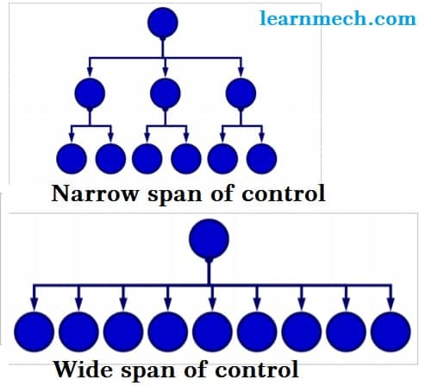

1. Narrow span of control
- Advantages:
• Close supervision
• Close control of subordinates
• Fast communication
- Disadvantages:
• Too much control
• Many levels of management
• High costs
• Excessive distance between lowest level and highest level
- 2. Wide span of control:
- Wide span of control means a single manager or supervisor oversees a large number of subordinates. This gives rise to a flat organizational structure.
- Advantages:
• More Delegation of Authority
• Development of Managers
• Clear policies
- Disadvantages:
• Overloaded supervisors
• Danger of superiors loss of control
• Requirement of highly trained managerial personnel
• Block in decision making
Factors affecting span of control

1. Qualification and Qualities

If the superiors and subordinates are well-qualified, trained, experienced, and if they are experts in their jobs then the span of control will be wide and vice-versa.

2. Level of Management

If the superiors are working at the top-level of management, then they have more responsibilities. Therefore, their span of control will be narrow and vice-versa.

3. Nature of Work

If the work is difficult then the span of control is narrow and vice-versa.

4. Superior - Subordinates Relationship

If there are good relations between the superior and subordinates, then the span of control will be wide and vice-versa.

5. Degree of Centralisation

Under decentralisation, the superior has to take fewer decisions. Therefore, he can have a wide span of control. However, under centralisation, the superior has to take many decisions. Therefore, he should have a narrow span of control.

6. Use of Communication Technology

If face-to-face communication is used, then the span of control will be narrow. However, if electronic devices are used for communication then the span of control will be wide.

7. Financial position of the Prganisation

If the organisation has a good financial position, then it can have a narrow span of control. This is because a narrow span requires more managers. More managers will increase the compensation or wage bill of the organisation. However, if the organisation has a bad financial position, then it will be forced to have a wide span of control.

8. Clearity of Plans and Responsibilities

If the plans are clear and if the responsibilities are well-defined, then the span of control will be wide. This is because the subordinates will not have to go and consult their superior repeatedly for getting orders and guidance.

9. Time available for Subordinates

If the superior is busy with another work, and if he has less time for his subordinates then his span of control will be narrow and vice-versa.

10. Faith and Trust in Subordinates

If the superior has good faith, trust and confidence in his subordinates then the span of control can be wider.
Delegation
A manager alone cannot perform all the tasks assigned to him. In order to meet the targets, the manager should delegate authority. Delegation of Authority means division of authority and powers downwards to the subordinate. Delegation is about entrusting someone else to do parts of your job. Delegation of authority can be defined as subdivision and sub-allocation of powers to the subordinates in order to achieve effective results.

Elements of Delegation
- Authority - in context of a business organization, authority can be defined as the power and right of a person to use and allocate the resources efficiently, to take decisions and to give orders so as to achieve the organizational objectives. Authority must be well- defined. All people who have the authority should know what is the scope of their authority is and they shouldn’t misutilize it. Authority is the right to give commands, orders and get the things done. The top level management has greatest authority.
Authority always flows from top to bottom. It explains how a superior gets work done from his subordinate by clearly explaining what is expected of him and how he should go about it. Authority should be accompanied with an equal amount of responsibility. Delegating the authority to someone else doesn’t imply escaping from accountability. Accountability still rest with the person having the utmost authority.
- Responsibility - is the duty of the person to complete the task assigned to him. A person who is given the responsibility should ensure that he accomplishes the tasks assigned to him. If the tasks for which he was held responsible are not completed, then he should not give explanations or excuses. Responsibility without adequate authority leads to discontent and dissatisfaction among the person. Responsibility flows from bottom to top. The middle level and lower level management holds more responsibility. The person held responsible for a job is answerable for it. If he performs the tasks assigned as expected, he is bound for praises. While if he doesn’t accomplish tasks assigned as expected, then also he is answerable for that.
- Accountability - means giving explanations for any variance in the actual performance from the expectations set. Accountability can not be delegated. For example, if ’A’ is given a task with sufficient authority, and ’A’ delegates this task to B and asks him to ensure that task is done well, responsibility rest with ’B’, but accountability still rest with ’A’. The top level management is most accountable. Being accountable means being innovative as the person will think beyond his scope of job. Accountability, in short, means being answerable for the end result. Accountability can’t be escaped. It arises from responsibility.
For achieving delegation, a manager has to work in a system and has to perform following steps : -
- Assignment of tasks and duties
- Granting of authority
- Creating responsibility and accountability
Delegation of authority is the base of superior-subordinate relationship, it involves following steps:-
- Assignment of Duties - The delegator first tries to define the task and duties to the subordinate. He also has to define the result expected from the subordinates. Clarity of duty as well as result expected has to be the first step in delegation.
- Granting of authority - Subdivision of authority takes place when a superior divides and shares his authority with the subordinate. It is for this reason, every subordinate should be given enough independence to carry the task given to him by his superiors. The managers at all levels delegate authority and power which is attached to their job positions. The subdivision of powers is very important to get effective results.
- Creating Responsibility and Accountability - The delegation process does not end once powers are granted to the subordinates. They at the same time have to be obligatory towards the duties assigned to them. Responsibility is said to be the factor or obligation of an individual to carry out his duties in best of his ability as per the directions of superior. Responsibility is very important. Therefore, it is that which gives effectiveness to authority. At the same time, responsibility is absolute and cannot be shifted. Accountability, on the others hand, is the obligation of the individual to carry out his duties as per the standards of performance. Therefore, it is said that authority is delegated, responsibility is created and accountability is imposed. Accountability arises out of responsibility and responsibility arises out of authority. Therefore, it becomes important that with every authority position an equal and opposite responsibility should be attached.
Therefore every manager,i.e.,the delegator has to follow a system to finish up the delegation process. Equally important is the delegatee’s role which means his responsibility and accountability is attached with the authority over to here.

Relationship between Authority and Responsibility
Authority is the legal right of person or superior to command his subordinates while accountability is the obligation of individual to carry out his duties as per standards of performance Authority flows from the superiors to subordinates,in which orders and instructions are given to subordinates to complete the task. It is only through authority, a manager exercises control. In a way through exercising the control the superior is demanding accountability from subordinates. If the marketing manager directs the sales supervisor for 50 units of sale to be undertaken in a month. If the above standards are not accomplished, it is the marketing manager who will be accountable to the chief executive officer. Therefore, we can say that authority flows from top to bottom and responsibility flows from bottom to top. Accountability is a result of responsibility and responsibility is result of authority. Therefore, for every authority an equal accountability is attached.

Differences between Authority and Responsibility
Authority | Responsibility
It is the legal right of a person or a superior to command his subordinates. | It is the obligation of subordinate to perform the work assigned to him.
Authority is attached to the position of a superior in concern. | Responsibility arises out of superior-subordinate relationship in which subordinate agrees to carry out duty given to him.
Authority can be delegated by a superior to a subordinate | Responsibility cannot be shifted and is absolute
It flows from top to bottom. | It flows from bottom to top.

Bottom of Form

Delegation of authority is a process in which the authority and powers are divided and shared amongst the subordinates. When the work of a manager gets beyond his capacity, there should be some system of sharing the work. This is how delegation of authority becomes an important tool in organization function. Through delegation, a manager, in fact, is multiplying himself by dividing/multiplying his work with the subordinates. The importance of delegation can be justified by -
- Through delegation, a manager is able to divide the work and allocate it to the subordinates. This helps in reducing his work load so that he can work on important areas such as - planning, business analysis etc.
- With the reduction of load on superior, he can concentrate his energy on important and critical issues of concern. This way he is able to bring effectiveness in his work as well in the work unit. This effectivity helps a manager to prove his ability and skills in the best manner.
- Delegation of authority is the ground on which the superior-subordinate relationship stands. An organization functions as the authority flows from top level to bottom. This in fact shows that through delegation, the superior-subordinate relationship become meaningful. The flow of authority is from top to bottom which is a way of achieving results.
- Delegation of authority in a way gives enough room and space to the subordinates to flourish their abilities and skill. Through delegating powers, the subordinates get a feeling of importance. They get motivated to work and this motivation provides appropriate results to a concern. Job satisfaction is an important criterion to bring stability and soundness in the relationship between superior and subordinates. Delegation also helps in breaking the monotony of the subordinates so that they can be more creative and efficient.
Delegation of authority is not only helpful to the subordinates but it also helps the managers to develop their talents and skills. Since the manager get enough time through delegation to concentrate on important issues, their decision-making gets strong and in a way they can flourish the talents which are required in a manager. Through granting powers and getting the work done, helps the manager to attain communication skills, supervision and guidance, effective motivation and the leadership traits are flourished. Therefore it is only through delegation, a manager can be tested on his traits.
- Delegation of authority is help to both superior and subordinates. This, in a way, gives stability to a concern’s working. With effective results, a concern can think of creating more departments and divisions flow working. This will require creation of more managers which can be fulfilled by shifting the experienced, skilled managers to these positions. This helps in both virtual as well as horizontal growth which is very important for a concern’s stability.
Therefore, from the above points, we can justify that delegation is not just a process but it is a way by which manager multiples himself and is able to bring stability, ability and soundness to a concern.
Centralization & Decentralization
Centralization is said to be a process where the concentration of decision making is in a few hands. All the important decision and actions at the lower level, all subjects and actions at the lower level are subject to the approval of top management. According to Allen, “Centralization” is the systematic and consistent reservation of authority at central points in the organization. The implication of centralization can be:-
- Reservation of decision making power at top level.
- Reservation of operating authority with the middle level managers.
- Reservation of operation at lower level at the directions of the top level.
Under centralization, the important and key decisions are taken by the top management and the other levels are into implementations as per the directions of top level. For example, in a business concern, the father & son being the owners decide about the important matters and all the rest of functions like product, finance, marketing, personnel, are carried out by the department heads and they have to act as per instruction and orders of the two people. Therefore in this case, decision making power remain in the hands of father & son.
On the other hand, Decentralization is a systematic delegation of authority at all levels of management and in all of the organization. In a decentralization concern, authority in retained by the top management for taking major decisions and framing policies concerning the whole concern. Rest of the authority may be delegated to the middle level and lower level of management.
The degree of centralization and decentralization will depend upon the amount of authority delegated to the lowest level. According to Allen, “Decentralization refers to the systematic effort to delegate to the lowest level of authority except that which can be controlled and exercised at central points.
Decentralization is not the same as delegation. In fact, decentralization is all extension of delegation. Decentralization pattern is wider is scope and the authorities are diffused to the lowest most level of management. Delegation of authority is a complete process and takes place from one person to another. While decentralization is complete only when fullest possible delegation has taken place. For example, the general manager of a company is responsible for receiving the leave application for the whole of the concern. The general manager delegates this work to the personnel manager who is now responsible for receiving the leave applicants. In this situation delegation of authority has taken place. On the other hand, on the request of the personnel manager, if the general manager delegates this power to all the departmental heads at all level, in this situation decentralization has taken place. There is a saying that “Everything that increasing the role of subordinates is decentralization and that decreases the role is centralization”. Decentralization is wider in scope and the subordinate’s responsibility increase in this case. On the other hand, in delegation the managers remain answerable even for the acts of subordinates to their superiors.

Implications of Decentralization
- There is less burden on the Chief Executive as in the case of centralization.
- In decentralization, the subordinates get a chance to decide and act independently which develops skills and capabilities. This way the organization is able to process reserve of talents in it.
- In decentralization, diversification and horizontal can be easily implanted.
- In decentralization, concern diversification of activities can place effectively since there is more scope for creating new departments. Therefore, diversification growth is of a degree.
- In decentralization structure, operations can be coordinated at divisional level which is not possible in the centralization set up.
- In the case of decentralization structure, there is greater motivation and morale of the employees since they get more independence to act and decide.
- In a decentralization structure, co-ordination to some extent is difficult to maintain as there are lot many department divisions and authority is delegated to maximum possible extent, i.e., to the bottom most level delegation reaches. Centralization and decentralization are the categories by which the pattern of authority relationships became clear. The degree of centralization and de-centralization can be affected by many factors like nature of operation, volume of profits, number of departments, size of a concern, etc. The larger the size of a concern, a decentralization set up is suitable in it.

Delegation and Decentralization

Basis | Delegation | Decentralization
Meaning | Managers delegate some of their function and authority to their subordinates. | Right to take decisions is shared by top management and other level of management.
Scope | Scope of delegation is limited as superior delegates the powers to the subordinates on individual bases. | Scope is wide as the decision making is shared by the subordinates also.
Responsibility | Responsibility remains of the managers and cannot be delegated | Responsibility is also delegated to subordinates.
Freedom of Work | Freedom is not given to the subordinates as they have to work as per the instructions of their superiors. | Freedom to work can be maintained by subordinates as they are free to take decision and to implement it.
Nature | It is a routine function | It is an important decision of an enterprise.
Need on purpose | Delegation is important in all concerns whether big or small. No enterprises can work without delegation. | Decentralization becomes more important in large concerns and it depends upon the decision made by the enterprise, it is not compulsory.
Grant of Authority | The authority is granted by one individual to another. | It is a systematic act which takes place at all levels and at all functions in a concern.
Grant of Responsibility | Responsibility cannot be delegated | Authority with responsibility is delegated to subordinates.
Degree | Degree of delegation varies from concern to concern and department to department. | Decentralization is total by nature. It spreads throughout the organization i.e. at all levels and all functions
Process | Delegation is a process which explains superior subordinates relationship | It is an outcome which explains relationship between top management and all other departments.
Essentiality | Delegation is essential of all kinds of concerns | Decentralization is a decisions function by nature.
Significance | Delegation is essential for creating the organization | Decentralization is an optional policy at the discretion of top management.
Withdrawal | Delegated authority can be taken back. | It is considered as a general policy of top management and is applicable to all departments.
Freedom of Action | Very little freedom to the subordinates | Considerable freedom
Decentralization can be called as extension of delegation. When delegation of authority is done to the fullest possible extent, it gives use to decentralization.

